Reyes, Aaron Christian D. Web Development

BSCS – 3E Activity 3

**Home Page**

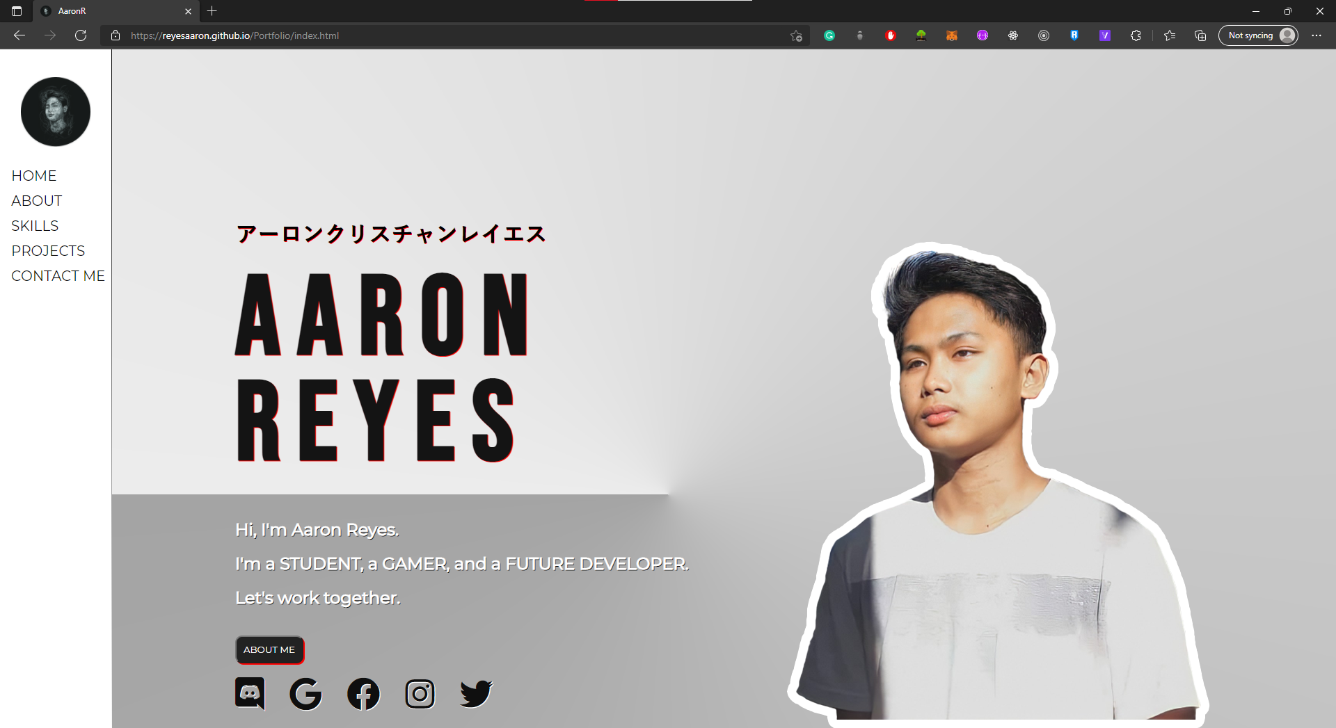

**About Page**

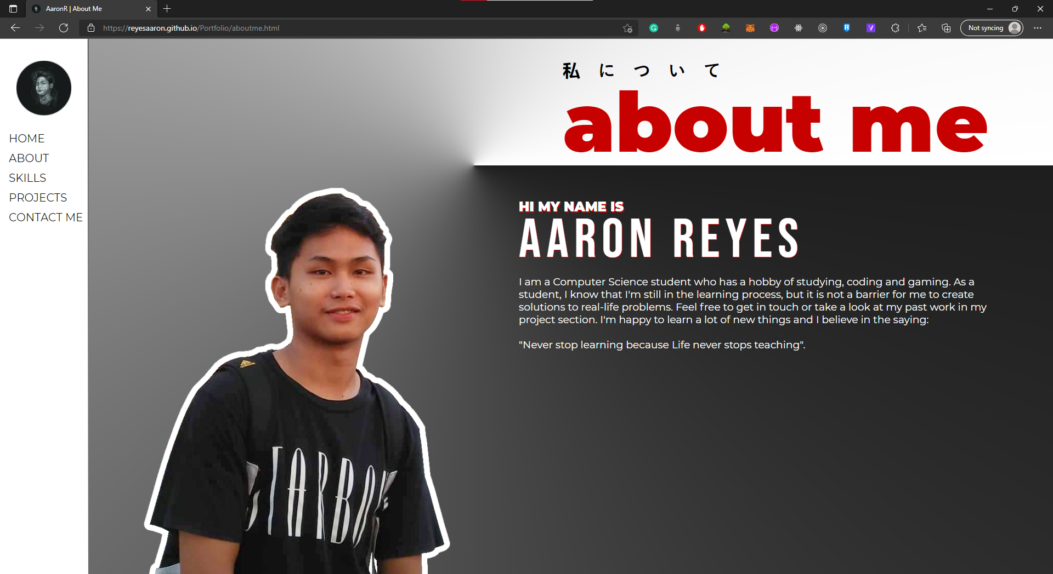

**Skills Page**

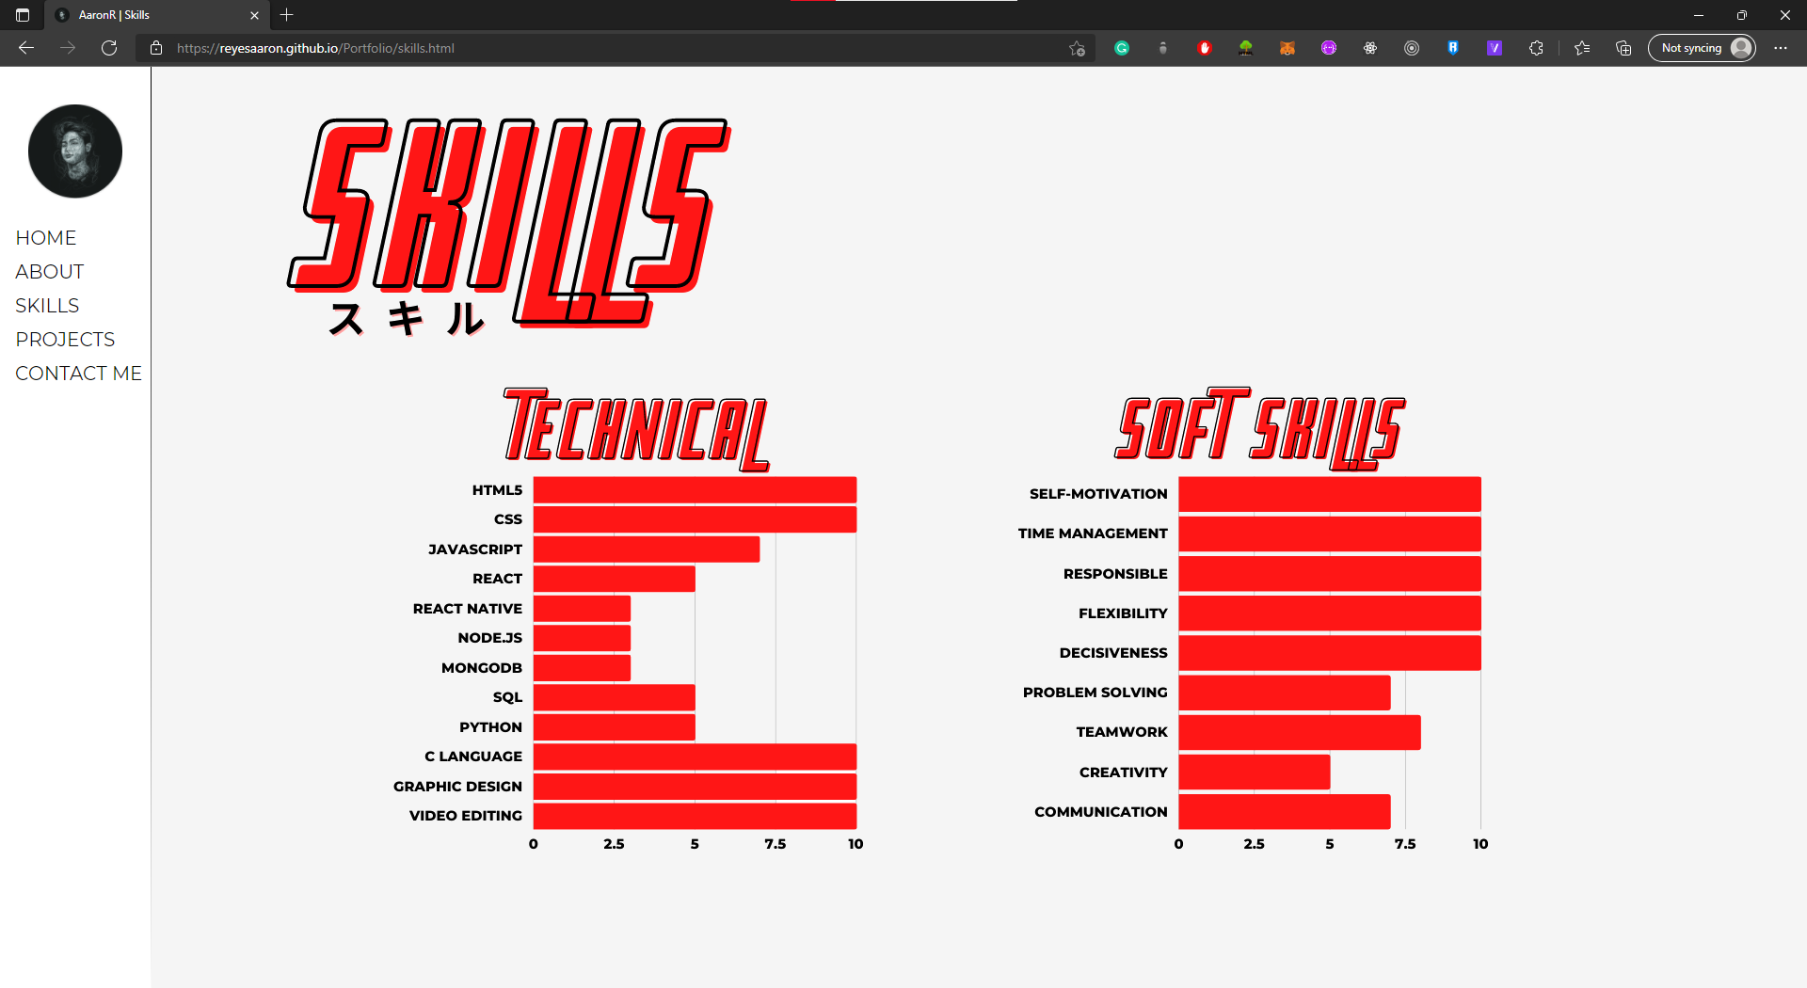

**Projects Page**

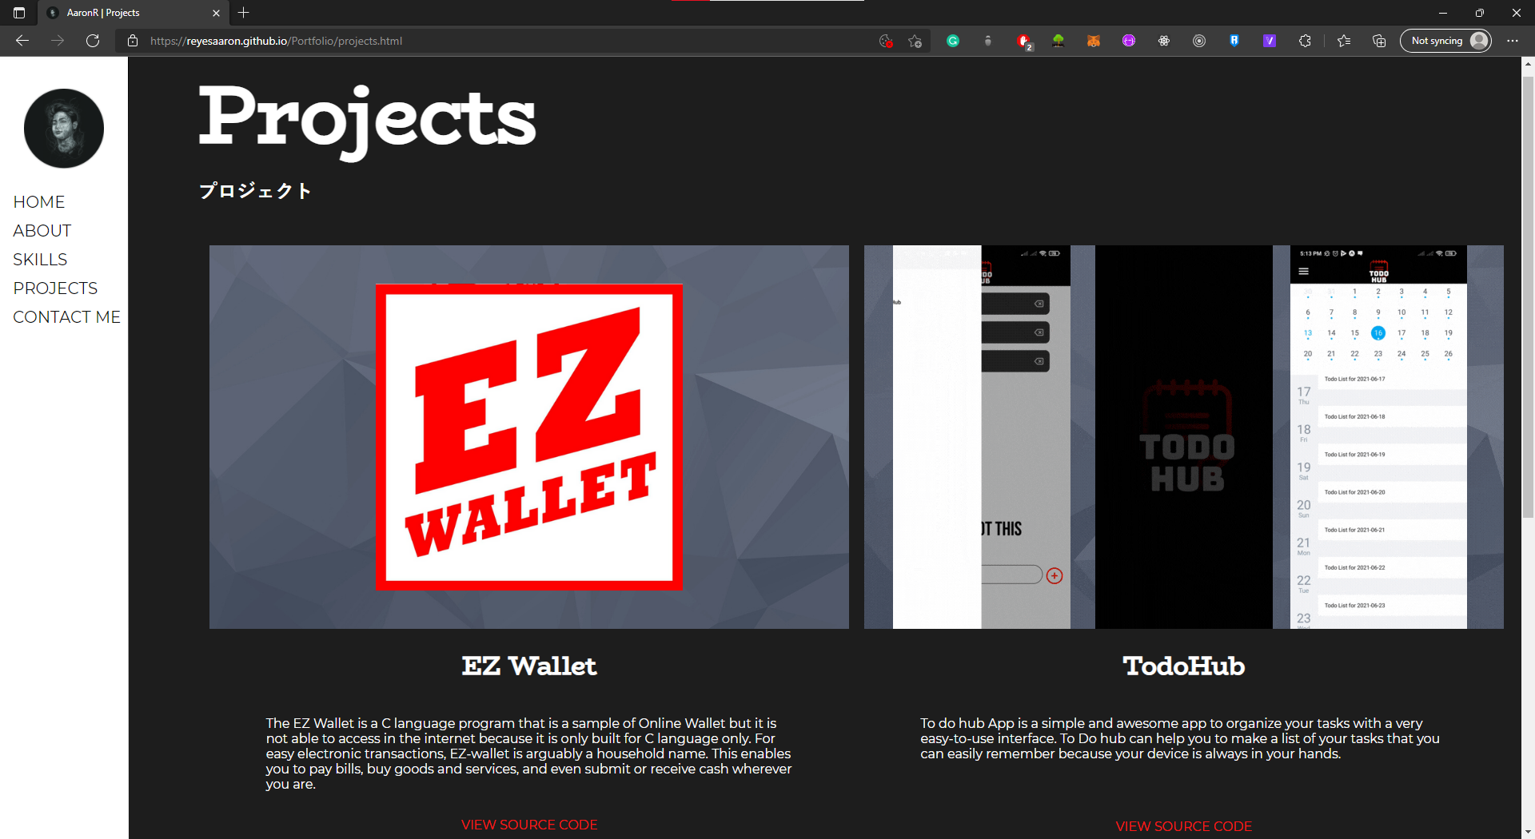

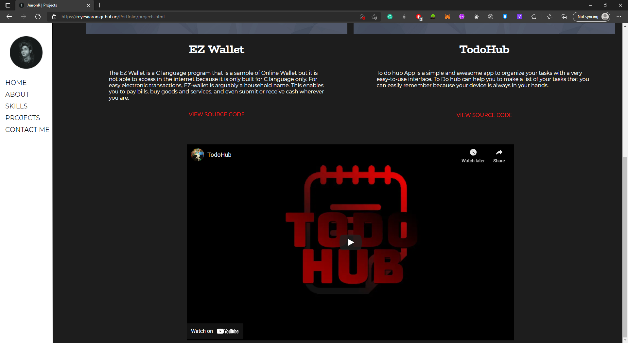

**Contact Me Page**

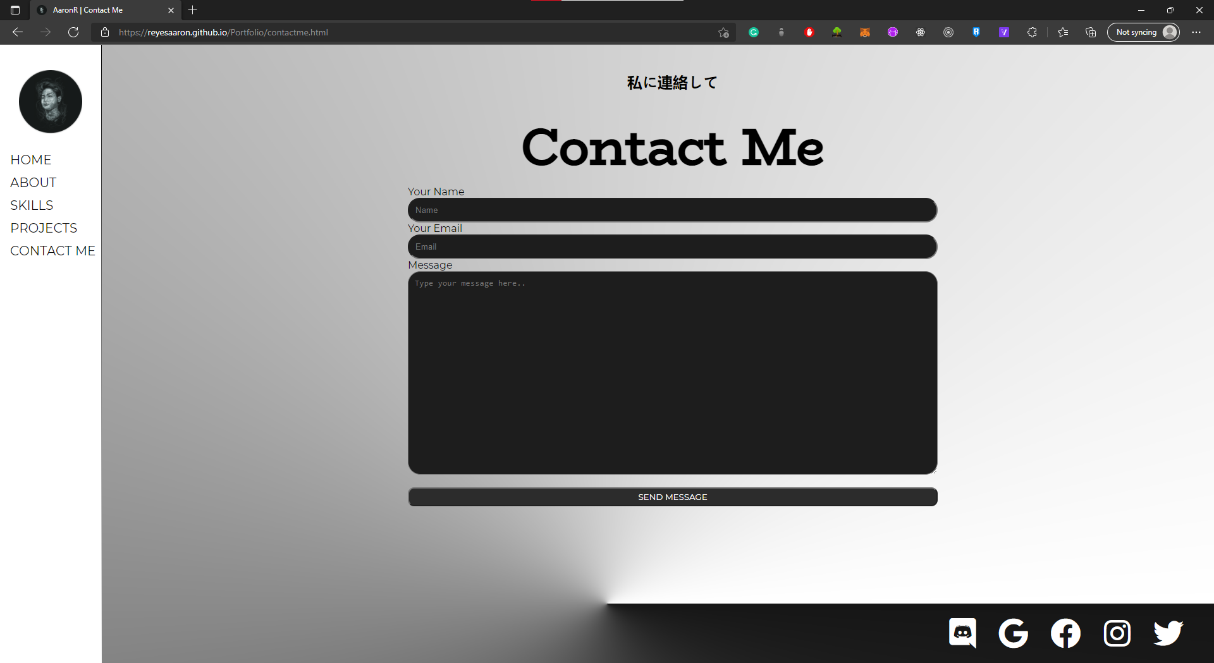

**index.html**

<!DOCTYPE html>

<html lang="en">

<head>

    <meta charset="UTF-8">

    <meta http-equiv="X-UA-Compatible" content="IE=edge">

    <meta name="viewport" content="width=device-width, initial-scale=1.0">

    <link rel="stylesheet" href="style.css">

    <link href="https://fonts.googleapis.com/css2?family=Bebas+Neue&family=Montserrat&display=swap" rel="stylesheet">

    <link rel="icon" type="image/png" href="./image/Icon.png">

    <link rel="stylesheet" href="https://pro.fontawesome.com/releases/v5.10.0/css/all.css" integrity="sha384-AYmEC3Yw5cVb3ZcuHtOA93w35dYTsvhLPVnYs9eStHfGJvOvKxVfELGroGkvsg+p" crossorigin="anonymous"/>

    <title>AaronR</title>

</head>

<body class="homebody">

    <nav>

        <!-- Side navigation -->

        <div class="sidenav">

            <img src="./image/Icon.png" alt="icon" class="icon">

            <a href="./index.html">HOME</a>

            <a href="./aboutme.html">ABOUT</a>

            <a href="./skills.html">SKILLS</a>

            <a href="./projects.html">PROJECTS</a>

            <a href="./contactme.html">CONTACT ME</a>

        </div>

    </nav>

  <!-- Page content -->

  <div class="main">

    <img src="./image/Me.png" alt="me" class="img">

        <h1 class="jap">アーロンクリスチャンレイエス</h1>

        <h1 class="name">AARON<br>REYES</h1>

        <br>

        <h2>Hi, I'm <span class="a">Aaron Reyes</span>.</h2>

        <h2>I'm a <span class="b">STUDENT, a GAMER, and a FUTURE DEVELOPER.</span></h2>

        <h2>Let's <span class="c">work together</span>.</h2>

        <a href="./aboutme.html"><button>ABOUT ME</button></a>

        <div class="socmed">

            <a href="https://github.com/reyesaaron" target="_blank"><i class="fab fa-discord fa-3x"></i></a>

            <a href="mailto: theaaronreyes02@gmail.com"><i class="fab fa-google fa-3x"></i></a>

            <a href="https://www.facebook.com/AaronReyesx/" target="_blank"><i class="fab fa-facebook fa-3x"></i></a>

            <a href="https://www.instagram.com/aaronreyesxz/" target="_blank"><i class="fab fa-instagram fa-3x"></i></a>

            <a href="https://twitter.com/Aaronreyesxz" target="_blank"><i class="fab fa-twitter fa-3x"></i></a>

        </div>

  </div>

</body>

</html>

**aboutme.html**

<!DOCTYPE html>

<html lang="en">

<head>

    <meta charset="UTF-8">

    <meta http-equiv="X-UA-Compatible" content="IE=edge">

    <meta name="viewport" content="width=device-width, initial-scale=1.0">

    <link rel="stylesheet" href="style.css">

    <link href="https://fonts.googleapis.com/css2?family=Bebas+Neue&family=BioRhyme&family=Montserrat:wght@400;900&display=swap" rel="stylesheet">

    <link rel="icon" type="image/png" href="./image/Icon.png">

    <link rel="stylesheet" href="https://pro.fontawesome.com/releases/v5.10.0/css/all.css" integrity="sha384-AYmEC3Yw5cVb3ZcuHtOA93w35dYTsvhLPVnYs9eStHfGJvOvKxVfELGroGkvsg+p" crossorigin="anonymous"/>

    <title>AaronR | About Me</title>

</head>

<body class="aboutmebody">

    <nav>

        <!-- Side navigation -->

        <div class="sidenav">

            <img src="./image/Icon.png" alt="icon" class="icon">

            <a href="./index.html">HOME</a>

            <a href="./aboutme.html">ABOUT</a>

            <a href="./skills.html">SKILLS</a>

            <a href="./projects.html">PROJECTS</a>

            <a href="./contactme.html">CONTACT ME</a>

        </div>

    </nav>

    <div class="aboutmemain">

        <img src="./image/me2.png" alt="me">

        <div>

            <h1  class="japaboutme">私について</h1>

            <span id="aboutme" class="aboutmespan">about me</span>

        </div>

        <div>

            <h2>HI MY NAME IS</h2>

            <h1 class="name">Aaron Reyes</h1>

        </div>

        <div>

            <h3>I am a <span class="aboutmespan">Computer Science student</span> who has a hobby of <span class="aboutmespan">studying</span>, <span class="aboutmespan">coding</span> and <span class="aboutmespan">gaming</span>. As a student, I know that I'm still in the learning process, but it is not a barrier for me to create solutions to real-life problems.

                Feel free to get in touch or take a look at my past work in my project section. I'm happy to learn a lot of new things and I believe in the saying: <br><br>

                <span class="aboutmespan">"Never stop learning because Life never stops teaching".</span></h3>

        </div>

    </div>

</body>

</html>

**Skills.html**

<!DOCTYPE html>

<html lang="en">

<head>

    <meta charset="UTF-8">

    <meta http-equiv="X-UA-Compatible" content="IE=edge">

    <meta name="viewport" content="width=device-width, initial-scale=1.0">

    <link rel="stylesheet" href="style.css">

    <link href="https://fonts.googleapis.com/css2?family=Bebas+Neue&family=Montserrat:wght@400;900&display=swap" rel="stylesheet">

    <link rel="icon" type="image/png" href="./image/Icon.png">

    <title>AaronR | Skills</title>

</head>

<body class="skillsbody">

    <nav>

        <!-- Side navigation -->

        <div class="sidenav">

            <img src="./image/Icon.png" alt="icon" class="icon">

            <a href="./index.html">HOME</a>

            <a href="./aboutme.html">ABOUT</a>

            <a href="./skills.html">SKILLS</a>

            <a href="./projects.html">PROJECTS</a>

            <a href="./contactme.html">CONTACT ME</a>

        </div>

    </nav>

    <div class="skillsmain">

        <img src="./image/skills (1).png" alt="skills" class="skills"><br>

        <img src="./image/technical skills.png" alt="myskills" class="myskills">

        <img src="./image/SOFT SKILLS.png" alt="myskills" class="myskillstwo">

    </div>

</body>

</html>

**projects.html**

<!DOCTYPE html>

<html lang="en">

<head>

    <meta charset="UTF-8">

    <meta http-equiv="X-UA-Compatible" content="IE=edge">

    <meta name="viewport" content="width=device-width, initial-scale=1.0">

    <link rel="stylesheet" href="style.css">

    <link rel="icon" type="image/png" href="./image/Icon.png">

    <link href="https://fonts.googleapis.com/css2?family=Bebas+Neue&family=BioRhyme&family=Montserrat:wght@400;900&display=swap" rel="stylesheet">

    <title>AaronR | Projects</title>

</head>

<body class="projectsbody">

    <nav>

        <!-- Side navigation -->

        <div class="sidenav">

            <img src="./image/Icon.png" alt="icon" class="icon">

            <a href="./index.html">HOME</a>

            <a href="./aboutme.html">ABOUT</a>

            <a href="./skills.html">SKILLS</a>

            <a href="./projects.html">PROJECTS</a>

            <a href="./contactme.html">CONTACT ME</a>

        </div>

    </nav>

    <div class="projectsmain">

        <h1 class="projecttitle">Projects</h1>

        <h2 class="japprojecttitle">プロジェクト</h2>

        <div class="projects">

            <div class="ewallet">

                <div class="ewallethover"></div>

                    <h1 class="ettitle">EZ Wallet</h1>

                    <p> The EZ Wallet is a C language program that is a sample of Online Wallet but it is not able to access in the internet because it is only built for C language only.

                        For easy electronic transactions, EZ-wallet is arguably a household name. This enables you to pay bills, buy goods and services, and even submit or receive cash wherever you are.

                    </p>

                <p><a href="https://github.com/reyesaaron/ewallet" target="_blank">VIEW SOURCE CODE</a></p>

            </div>

            <div class="todohub">

                <div class="todohubhover"></div>

                <h1 class="ettitle">TodoHub</h1>

                <p>To do hub App is a simple and awesome app to organize your tasks with a very easy-to-use interface.

                    To Do hub can help you to make a list of your tasks that you can easily remember because your device is always in your hands.

                </p>

                <p  class="sourcecode"><a href="https://github.com/reyesaaron/todohub" target="_blank">VIEW SOURCE CODE</a></p>

            </div>

        </div>

        <div class="demo">

            <iframe width="1000" height="600" src="https://www.youtube.com/embed/9NpQoscuKsg" title="YouTube video player" frameborder="0" allow="accelerometer; autoplay; clipboard-write; encrypted-media; gyroscope; picture-in-picture" allowfullscreen></iframe>

        </div>

    </div>

</body>

</html>

**contactme.html**

<!DOCTYPE html>

<html lang="en">

<head>

    <meta charset="UTF-8">

    <meta http-equiv="X-UA-Compatible" content="IE=edge">

    <meta name="viewport" content="width=device-width, initial-scale=1.0">

    <link rel="stylesheet" href="style.css">

    <link href="https://fonts.googleapis.com/css2?family=Bebas+Neue&family=BioRhyme&family=Montserrat:wght@400;900&display=swap" rel="stylesheet">

    <link rel="icon" type="image/png" href="./image/Icon.png">

    <link rel="stylesheet" href="https://pro.fontawesome.com/releases/v5.10.0/css/all.css" integrity="sha384-AYmEC3Yw5cVb3ZcuHtOA93w35dYTsvhLPVnYs9eStHfGJvOvKxVfELGroGkvsg+p" crossorigin="anonymous"/>

    <title>AaronR | Contact Me</title>

</head>

<body class="contactsbody">

    <nav>

        <!-- Side navigation -->

        <div class="sidenav">

            <img src="./image/Icon.png" alt="icon" class="icon">

            <a href="./index.html">HOME</a>

            <a href="./aboutme.html">ABOUT</a>

            <a href="./skills.html">SKILLS</a>

            <a href="./projects.html">PROJECTS</a>

            <a href="./contactme.html">CONTACT ME</a>

        </div>

    </nav>

    <div class="contactsmain">

        <h2>私に連絡して</h2>

        <h1>Contact Me</h1>

        <form action="https://formsubmit.co/theaaronreyes02@gmail.com" method="POST" id="contactform">

            <label for="name">Your Name</label>

            <input type="text" name="name" placeholder="Name" required>

            <label for="email">Your Email</label>

            <input type="email" name="email" placeholder="Email" required>

            <label for="subject">Message</label>

            <textarea id="subject" name="subject" placeholder="Type your message here.." required rows="20" cols="50"></textarea>

            <button type="submit">SEND MESSAGE</button>

          </form>

        <div class="socmedcontacts">

            <a href="https://github.com/reyesaaron" target="_blank"><i class="fab fa-discord fa-3x"></i></a>

            <a href="mailto: theaaronreyes02@gmail.com"><i class="fab fa-google fa-3x"></i></a>

            <a href="https://www.facebook.com/AaronReyesx/" target="_blank"><i class="fab fa-facebook fa-3x"></i></a>

            <a href="https://www.instagram.com/aaronreyesxz/" target="_blank"><i class="fab fa-instagram fa-3x"></i></a>

            <a href="https://twitter.com/Aaronreyesxz" target="_blank"><i class="fab fa-twitter fa-3x"></i></a>

        </div>

    </div>

</body>

</html>

**Style.css**

/* HOME PAGE */

body {

    font-family: 'Montserrat', sans-serif;

}

.homebody {

  background-image: url("./image/bg.png");

}

.sidenav {

    height: 100%; /* Full-height: remove this if you want "auto" height */

    width: 160px; /* Set the width of the sidebar */

    position: fixed; /* Fixed Sidebar (stay in place on scroll) */

    z-index: 1; /* Stay on top */

    top: 0; /* Stay at the top */

    left: 0;

    background-color: white; /* Black */

    overflow-x: hidden; /* Disable horizontal scroll */

    padding-top: 20px;

    border-right: solid 1px;

    border-image:

      linear-gradient(

        to bottom,

        black,

        rgba(0, 0, 0, 0)

      ) 1 100%;

  }

  .sidenav a {

    padding: 6px 8px 6px 16px;

    text-decoration: none;

    font-size: 20px;

    color: #0f0f0f;

    display: block;

  }

  .sidenav a:hover {

    color: #FF0000;

  }

  .main {

    margin-left: 20rem;

    padding: 0px 10px;

    margin: 15rem 50rem 0 20rem;

  }

  @media screen and (max-height: 450px) {

    .sidenav {padding-top: 15px;}

    .sidenav a {font-size: 18px;}

  }

.img {

    position: absolute;

    right: 150px;

    bottom: 0px;

    transition: transform 1s;

}

.img:hover{

  transform: scale(1.1);

}

.name {

    font-family: 'Bebas Neue';

    letter-spacing: 1.5rem;

    font-size: 10rem;

    line-height: 95%;

    margin: 0 0 20px 0;

    color: rgb(20, 20, 20);

}

.jap:hover, .name:hover{

    color: white;

    text-shadow: black 1px 1px;

}

.name, .jap {

  text-shadow: #FF0000 1px 1px;

}

.a:hover, .b:hover, .c:hover{

    color: #FF0000;

}

.main h2 {

    color: white;

    text-shadow: black 1px 1px;

}

.socmed i {

    color: #0f0f0f;

    margin-right: 2rem;

    transition: transform 0.2s;

}

.socmed i:hover {

    color: #FF0000;

    transform: scale(1.5);

}

.icon {

    height: 100px;

    width: 100px;

    margin: 20px 0 20px 30px;

}

.main button {

  margin: 20px 0;

  padding: 10px;

  border-radius: 10px;

  background-color: #222222;

  color: rgb(255, 255, 255);

  box-shadow: #FF0000 2px 2px;

  font-family: 'Montserrat', sans-serif;

  transition: transform 0.2s;

}

.main button:hover{

  transform: scale(1.3);

  background-color: white;

  color: black;

}

.socmed img {

  height: 100px;

  width: 100px;

  margin: 0px;

}

.socmed i {

  text-shadow:#ffffff 1px 1px;

}

/* ABOUT ME PAGE */

.aboutmebody {

  background-image: url("./image/ambg.png");

}

.aboutmemain {

  padding: 0px 10px;

  margin: 20px 0rem 0 13rem;

}

#aboutme {

  margin-left: 50rem;

  margin-top: 3.5rem;

  font-weight: 900;

  font-size: 150px;

  position: absolute;

  top: 5px;

  color: #c70000;

}

#aboutme:hover{

  color: rgb(36, 36, 36)

}

.japaboutme {

  margin: 2rem 0 0 50rem;

  letter-spacing: 2rem;

}

.japaboutme:hover {

  color: #c70000;

}

.aboutmemain img {

  max-height: 45rem;

  margin-left: 2rem;

  position: absolute;

  bottom: 0%;

  transition: transform 1s;

}

.aboutmemain img:hover{

  transform: scale(1.2);

}

.aboutmemain h3{

  color: white;

  font-weight: 100;

  margin: 1rem 5rem 0 45rem;

}

.aboutmemain h2 {

text-shadow: #c70000 1px 2px;

color: white;

margin: 13rem 5rem 0 45rem;

}

.aboutmemain .name {

font-weight: 100;

margin: 0rem 5rem 0 45rem;

font-size: 100px;

color: white;

font-family: 'Bebas Neue';

letter-spacing: 10px;

transition: transform 1s;

}

.aboutmemain .name:hover{

  transform: scale(1.1);

  text-shadow: #c70000 1px 2px;

}

.aboutmespan:hover{

color: #FF0000;

}

/* SKILLS PAGE */

.skillsbody {

  background-color: whitesmoke;

}

.skills {

  margin: 2rem;

}

.myskills{

  margin-left: 10rem;

}

.myskillstwo {

  margin-left: 10rem;

}

.skillsmain {

  padding: 0px 10px;

  margin-left: 15rem;

}

/* PROJECTS PAGE */

.projectsbody{

  background-color: #1d1d1d;

}

.projectsmain {

  color: white;

  margin-left: 15rem;

}

.projecttitle{

  font-family: 'BioRhyme', serif;

  align-self: center;

  font-size: 100px;

  margin: 0;

}

.projecttitle:hover, .japprojecttitle:hover{

  color: #FF0000;

  text-shadow: white 1px 2px;

}

.japprojecttitle {

  margin: 0;

}

.ewallet {

  width: 40%;

  display: flex;

  flex-direction: column;

  align-items: center;

  margin: 0 5rem;

}

.ezwallet {

  width: 30%;

}

.todohub img {

  width: 50%;

}

.projects {

  display: flex;

  justify-content: center;

  margin-top: 3rem;

  flex-wrap: wrap;

}

.todohub {

  width: 40%;

  display: flex;

  flex-direction: column;

  align-items: center;

  margin: 0 5rem;

}

.projects a {

  text-decoration: none;

  color: rgb(255, 21, 21);

}

.projects a:hover{

  color: white;

}

.ewallethover {

  width: 50rem;

  height: 30rem;

  background-repeat: no-repeat;

  background-image: url("./image/ezwallet.png");

  background-size: 50rem 30rem;

}

.ewallethover:hover{

  background-image: url("./image/ezwalletgif.gif");

}

.todohubhover {

  width: 50rem;

  height: 30rem;

  background-repeat: no-repeat;

  background-image: url("./image/todohub.png");

  background-size: 50rem 30rem;

}

.todohubhover:hover{

  background-image: url("./image/todohubhover.gif");

}

.ettitle {

  font-family: 'BioRhyme', serif;

}

.ettitle:hover{

  color: #FF0000;

  text-shadow: white 1px 2px;

}

.demo {

  display: flex;

  align-items: center;

  justify-content: center;

  margin-top: 4rem;

}

.sourcecode {

  margin-top: 3.5rem;

}

/* CONTACT ME PAGE */

.contactsbody {

  background-image: url("./image/CBG.png");

  background-size: 120rem 65rem;

  background-repeat: no-repeat;

}

.contactsmain {

  padding: 0px 10px;

  margin: 20px 0rem 0 13rem;

  display: flex;

  align-items: center;

  justify-content: center;

  flex-direction: column;

}

.contactsmain h1 {

  font-family: 'BioRhyme', serif;

  font-size: 5rem;

  margin: 0;

}

.contactsmain h1:hover, h2:hover {

  color: white;

}

#contactform {

  display: flex;

  flex-direction: column;

  width: 50%;

}

.contactsmain input, textarea{

  border-radius: 20px;

  padding: 10px;

  background-color:#1d1d1d;

  color: white;

}

.contactsmain button {

  margin: 20px 0;

  padding: 5px;

  border-radius: 10px;

  width: 100%;

  background-color: #2c2c2c;

  color: white;

  font-family: 'Montserrat', sans-serif;

}

.socmedcontacts {

  position:absolute;

  bottom: 1.5rem;

  right: 1rem;

}

.socmedcontacts i {

  color: #ffffff;

  margin-right: 2rem;

  transition: transform 0.2s;

}

.socmedcontacts i:hover {

  color:#c70000;

  transform: scale(1.5);

}